# IV. User Interface Design

## Main Screen

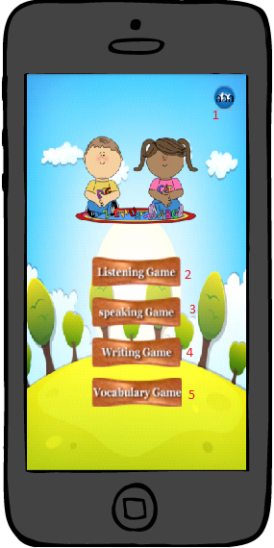

|  |  |  |  |  |
| --- | --- | --- | --- | --- |
| Button/HyberLink | | | | |
| No. | **Function** | **Description** | **Validation** | **Outcome** |
| 1 | Turn on/off music | Turn off music when it’s in on status or turn on music when it’s in off status | N/A | Change music’s status |
| 2 | Play listening game | Go to list of some listening games | N/A | Navigate to listening game screen |
| 3 | Play speaking game | Go to speaking game screen. | N/A | Navigate to speaking game screen |
| 4 | Play writing game | Go to list of some writing games | N/A | Navigate to writing game screen |
| 5 | Play vocabulary game | Go to vocabulary game screen. | N/A | Navigate to vocabulary game screen |

## Listening game menu screen

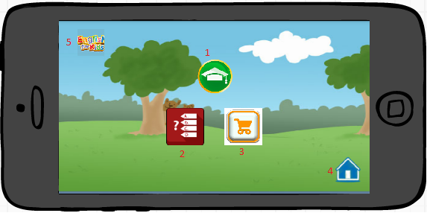

|  |  |  |  |  |  |  |
| --- | --- | --- | --- | --- | --- | --- |
| Fields | | | | | | |
| No. | **Name** | **Description** | **Mandatory** | **Control**  **Type** | **Data**  **Type** | **Length** |
| 5 | Logo | Logo | No | Image View | N/A | N/A |

|  |  |  |  |  |
| --- | --- | --- | --- | --- |
| Button/HyberLink | | | | |
| No. | **Function** | **Description** | **Validation** | **Outcome** |
| 1 | Play new words game | Go to “new words” game | No | Navigate to “new words” game |
| 2 | Play multi choice game | Go to “multi choice” game | No | Navigate to “multi choice” game |
| 3 | Play “ask and take” game | Go to “ask and take” game | No | Navigate to “ask and take” game |
| 4 | Back to “Home” | Go to “Main screen” | No | Navigate to “main screen” |

## New words game menu screen

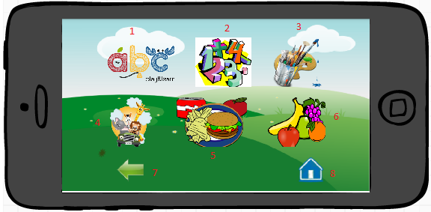

|  |  |  |  |  |
| --- | --- | --- | --- | --- |
| Button/HyberLink | | | | |
| No. | **Function** | **Description** | **Validation** | **Outcome** |
| 1 | Play Alphabet new word | Go to “alphabet new words” | No | Navigate to “New words” game with “Alphabet” |
| 2 | Play Number new word | Go to “Number new words” | No | Navigate to “New words” game with “Number” |
| 3 | Play Color new word | Go to “Color new words” | No | Navigate to “New words” game with “Color” |
| 4 | Play Animal new words | Go to “Animal new words” | No | Navigate to “new words” game with “Animal” |
| 5 | Play Food new words | Go to “Food new words” | No | Navigate to “new words” game with “Food” |
| 6 | Play Fruit new words | Go to “Fruit new words” | No | Navigate to “new words” game with “Fruit” |
| 7 | Back to menu | Back to “Listening menu game” | No | Navigate to “Listening menu game screen” |
| 8 | Back to home | Back to “Main” | No | Navigate to “Main screen” |

## New words game screen

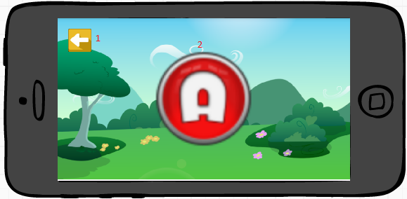

|  |  |  |  |  |  |  |
| --- | --- | --- | --- | --- | --- | --- |
| Fields | | | | | | |
| No. | **Name** | **Description** | **Mandatory** | **Control**  **Type** | **Data**  **Type** | **Length** |
| 2 | Image | Image with sound | No | Image Button | N/A | N/A |

|  |  |  |  |  |
| --- | --- | --- | --- | --- |
| Button/HyberLink | | | | |
| No. | **Function** | **Description** | **Validation** | **Outcome** |
| 1 | Back to menu | Back to “New words game menu” | No | Navigate to “New words game menu screen” |

## Multi choice game menu screen



|  |  |  |  |  |
| --- | --- | --- | --- | --- |
| Button/HyberLink | | | | |
| No. | **Function** | **Description** | **Validation** | **Outcome** |
| 1 | Play Alphabet multi choice | Go to “alphabet multi choice” | No | Navigate to “Multi choice” game with “Alphabet” |
| 2 | Play Number multi choice | Go to “Number multi choice” | No | Navigate to “Multi choice” game with “Number” |
| 3 | Play Color multi choice | Go to “Color multi choice” | No | Navigate to “Multi choice” game with “Color” |
| 4 | Play Animal multi choice | Go to “Animal multi choice” | No | Navigate to “Multi choice” game with “Animal” |
| 5 | Play Food multi choice | Go to “Food multi choice” | No | Navigate to “Multi choice” game with “Food” |
| 6 | Play Fruit multi choice | Go to “Fruit multi choice” | No | Navigate to “Multi choice” game with “Fruit” |
| 7 | Back to menu | Back to “Listening menu game” | No | Navigate to “Listening menu game screen” |
| 8 | Back to home | Back to “Main” | No | Navigate to “Main screen” |

## Multi choice game screen

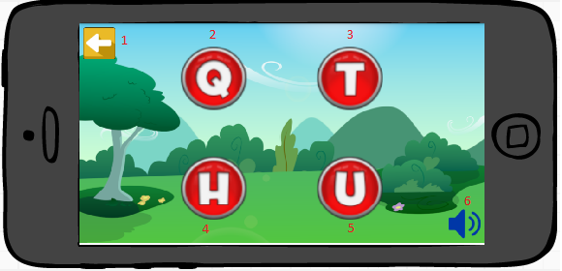

|  |  |  |  |  |
| --- | --- | --- | --- | --- |
| Button/HyberLink | | | | |
| No. | **Function** | **Description** | **Validation** | **Outcome** |
| 1 | Back to menu | Back to “Multi choice game menu” | No | Navigate to “Multi choice game menu screen” |
| 2 | Answer1 | Answer 1 | No | Navigate to next question |
| 3 | Answer2 | Answer 2 | No | Navigate to next question |
| 4 | Answer3 | Answer 3 | No | Navigate to next question |
| 5 | Answer4 | Answer 4 | No | Navigate to next question |
| 6 | Replay sound | Replay sound | No | Replay sound of the question |

## Listening Multi choice Result screen

|  |  |  |  |  |  |  |
| --- | --- | --- | --- | --- | --- | --- |
| Fields | | | | | | |
| No. | **Name** | **Description** | **Mandatory** | **Control**  **Type** | **Data**  **Type** | **Length** |
| 1 | Result | Result of 10 question | No | Dialog | N/A | N/A |

|  |  |  |  |  |
| --- | --- | --- | --- | --- |
| Button/HyberLink | | | | |
| No. | **Function** | **Description** | **Validation** | **Outcome** |
| 2 | Back to menu | Back to menu of multi choice game | No | Navigate to “Multi choice game menu screen” |
| 3 | Replay | Replay game | No | Replay game |
| 4 | Back to home | Back to listening game | No | Previous page |

## Ask and take

## Speaking game screen

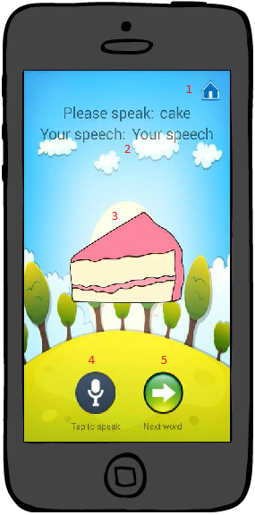

|  |  |  |  |  |  |  |
| --- | --- | --- | --- | --- | --- | --- |
| Fields | | | | | | |
| No. | **Name** | **Description** | **Mandatory** | **Control**  **Type** | **Data**  **Type** | **Length** |
| 2 | Question and answer | Show word required and word after speech | No | Text View | N/A | N/A |
| 3 | Image | Image with sound | No | Image button | N/A | N/A |

|  |  |  |  |  |
| --- | --- | --- | --- | --- |
| Button/HyberLink | | | | |
| No. | **Function** | **Description** | **Validation** | **Outcome** |
| 1 | Back to home | Back to home page | No | Navigate to “Main screen” |
| 4 | Speech | Tap to speech | No | Show Speech Recognition |
| 5 | Next | Next question | No | Show the next question |

## Writing menu game screen

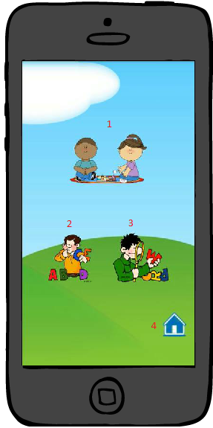

|  |  |  |  |  |
| --- | --- | --- | --- | --- |
| Button/HyberLink | | | | |
| No. | **Function** | **Description** | **Validation** | **Outcome** |
| 1 |  |  | No |  |
| 2 | Play missing word game | Go to “Arrange word” game | No | Navigate to “Arrange word game screen” |
| 3 | Play arrange word game | Go to “Missing word” game | No | Navigate to “Missing word game screen” |
| 4 | Back to home | Back to home page | No | Back to “Main screen” |

## A

## Arrange word game screen

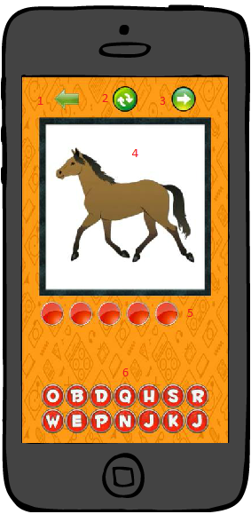

|  |  |  |  |  |  |  |
| --- | --- | --- | --- | --- | --- | --- |
| Fields | | | | | | |
| No. | **Name** | **Description** | **Mandatory** | **Control**  **Type** | **Data**  **Type** | **Length** |
| 4 | Image | Image | No | Image View | N/A | N/A |
| 5 | Answer | Show word has been chosen | No | Image View | N/A | N/A |
| 6 | Word | Suggest word | No | Image button | N/A | N/A |

|  |  |  |  |  |
| --- | --- | --- | --- | --- |
| Button/HyberLink | | | | |
| No. | **Function** | **Description** | **Validation** | **Outcome** |
| 1 | Back to menu | Back to “Writing menu” | No | Navigate to “Writing menu game screen” |
| 2 | Refresh | Refresh the question | No | Refresh the question |
| 3 | Next | Skip this question | No | Go to next quesion |

## Missing word game screen

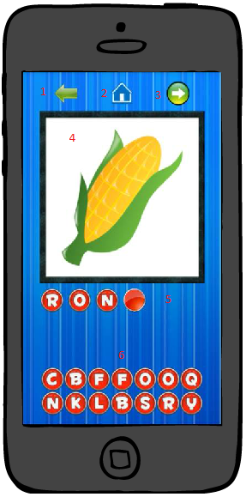

|  |  |  |  |  |  |  |
| --- | --- | --- | --- | --- | --- | --- |
| Fields | | | | | | |
| No. | **Name** | **Description** | **Mandatory** | **Control**  **Type** | **Data**  **Type** | **Length** |
| 4 | Image | Image | No | Image View | N/A | N/A |
| 5 | Answer | Show the answer | No | Image view | N/A | N/A |
| 6 | Word | Suggest word | No | Image button | N/A | N/A |

|  |  |  |  |  |
| --- | --- | --- | --- | --- |
| Button/HyberLink | | | | |
| No. | **Function** | **Description** | **Validation** | **Outcome** |
| 1 | Back to menu | Back to “Writing menu” | No | Navigate to “Writing menu game screen” |
| 2 | Home | Back to home page | No | Navigate to “Main screen” |
| 3 | Next | Skip this question | No | Go to next question |

## Vocabulary game screen

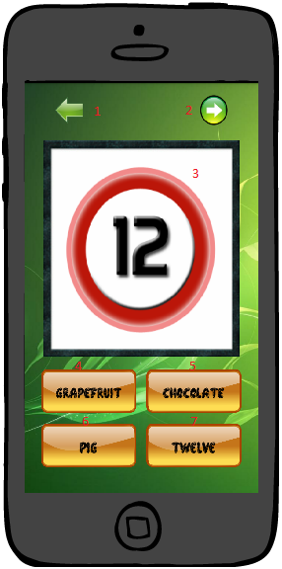

|  |  |  |  |  |  |  |
| --- | --- | --- | --- | --- | --- | --- |
| Fields | | | | | | |
| No. | **Name** | **Description** | **Mandatory** | **Control**  **Type** | **Data**  **Type** | **Length** |
| 3 | Image | Image | No | Image View | N/A | N/A |
| 4 | Answer1 | Suggest answer 1 | No | Image button | N/A | N/A |
| 5 | Answer2 | Suggest answer 2 | No | Image button | N/A | N/A |
| 6 | Answer3 | Suggest answer 3 | No | Image button | N/A | N/A |
| 7 | Answer4 | Suggest answer 4 | No | Image button | N/A | N/A |

|  |  |  |  |  |
| --- | --- | --- | --- | --- |
| Button/HyberLink | | | | |
| No. | **Function** | **Description** | **Validation** | **Outcome** |
| 1 | Home | Back to home page | No | Navigate to “Main screen” |
| 2 | Next | Skip this question | No | Go to next question |